

|  |  |
| --- | --- |
| Student name: | Kurmanbay Abilkaiyr, Aldiyar Kyzyrkhanov, Petr Tsekoyev |
| Group name: | CS-2114, CS-2113, CS-2107 |
| Teacher name: | Arailym Tleubayeva |
| Project name: | OSC Final Project - Report |
| Project type: | Group (3 Participants) |
| Number of words | ~1500 |

**List Of Figures**

1. Introduction

1.1. The outline of the project3

2. Main part

2.1. Task 1 – Adding new user5

2.2. Task 2 – Adding 3 Methods of Connecting to Internet5

2.2.1. Direct IP connection5

2.2.2. NAT eth0 and eth1 connection5

2.2.3. Proxy connection5

2.3. Task 3 – Linux Kernel5

2.3.1. Compiling custom Linux Kernel5

2.3.2. Making custom Linux Kernel Modules5

3. Conclusion

3.1. Reflection and summary18

4. References and bibliography materials

**1. Introduction**

**1.1. The outline of the project**

The completion of three tasks connected to the Operation Systems Concepts course and the fundamentals of Linux System Administration is detailed in this report of final project tasks. It comprises algorithms or techniques for resolving these particular issues, screenshots of the task's outcomes, evidence of the team's comprehension and practical expertise, and conclusions and findings. Five students worked together to complete the tasks, and a report in PDF format was produced.

Task 1: Adding a new user to the Ubuntu system.

Task 2: Connecting to the Internet using different methods such as a direct IP connection, NAT, and a proxy server.

Task 3: Involves developing a Linux Kernel module with basic Kernel structure.

**2. Main Part**

**2.1. Task 1 – Adding new user**

1) First we going to the root user mode by **Sudo su**

2) “**sudo adduser “name”** ” to add new user (username “**abeke**”, password “**abeke**”).

3) adding to this user sudo root permissions (“administrator permissions”).

4) Login as that user(Abeke).

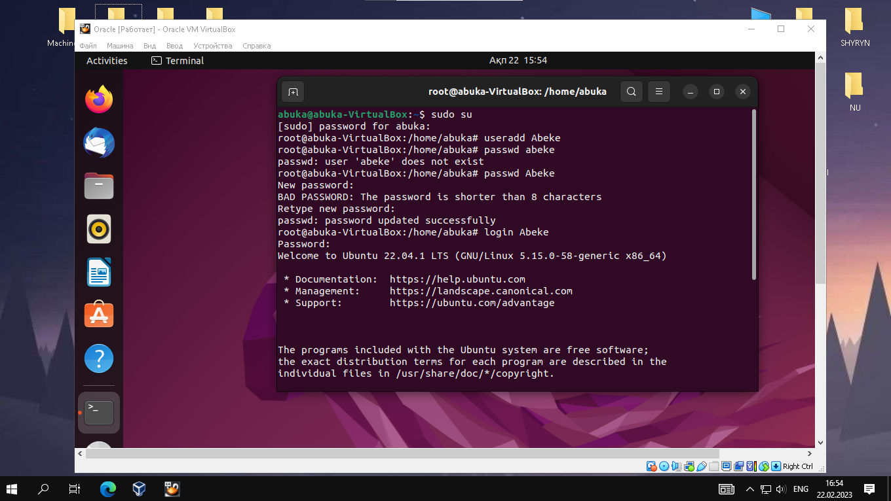

Picture 1. Creating new user “**Abeke**” with password “**abeke**” – sudo adduser student.

**sudo su Abeke** – to login as user.

**sudo login Abeke**- same as sudo su student.

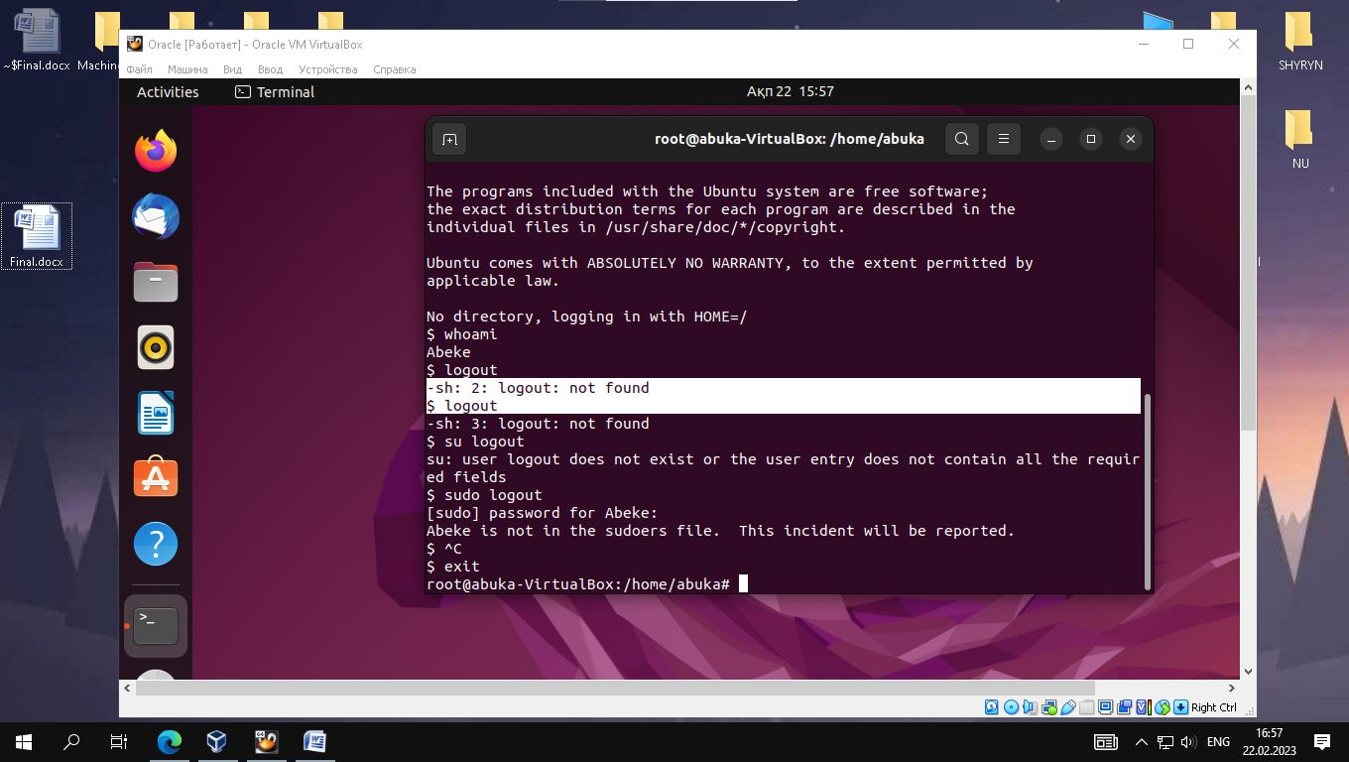

Picture 2. whoami – checking what user we are.

logout – logging out from user “student” to main user “noyan”.

**2.2. Task 2 – Adding 3 Methods of Connecting to Internet**

1. Direct IP connection to the Internet

2. Connection via NAT

3. Connection via a proxy server

I have used VirtualBox as the virtualization software and have created three virtual machines to demonstrate the three different methods.

1. Direct IP connection to the Internet: So have set up a "Bridged Adapter" network connection in VirtualBox for the first virtual machine. As a result, the virtual machine can share the same network as the host machine and have its own IP address. This indicates that the virtual machine has a direct connection to the Internet and may use it without further settings.

2. Connection via NAT: I have set up a "NAT" network connection in VirtualBox for the second virtual computer. As a result, the virtual machine can use NAT to access the Internet and share the host machine's IP address. The host computer translates all network traffic before it is delivered to the Internet, and the NAT network gives the virtual machine a private IP address.

3. Connection via a proxy server: In VirtualBox, I've set up a "Host only Adapter" network connection for the third virtual computer. As a result, the virtual machine can only communicate with the host machine and not with the public internet. I've set up the host system's Internet connection to use a proxy server so that the virtual machine can access the Internet through it. The virtual machine has been set up to utilize the IP address of the host machine as the proxy server address. The host computer receives all network traffic from the virtual machine in this manner, and the host system then transmits it to the proxy server for Internet access.

**2.2.1. Direct IP connection**

The VM must be given a direct IP address or DHCP address on the Internet in order for this form of internet connection to work. It enables direct communication with other devices across the local area network or the Internet. Thus we took the following actions: DHCP connection on enp03s was powered on after network-manager with dhcpcd installation, and it was checked.

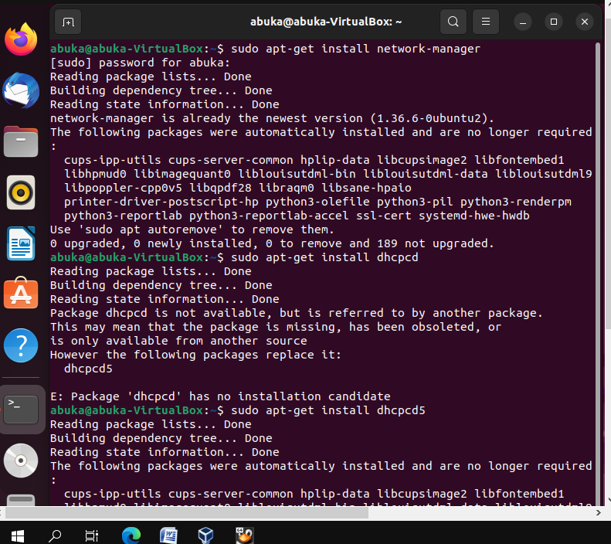

Picture 1. Installing network-manager with dhcpcd packets.

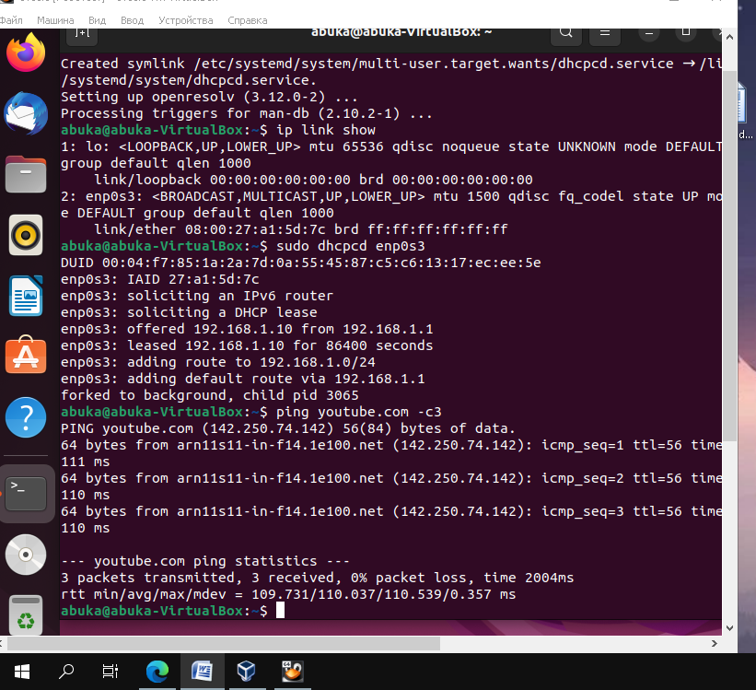

Picture 2. Adding DHCP connection to **enp0s3**, then checking this by pinging services (**youtube.com**).This is the way how to make this procedure with GUI of Ubuntu.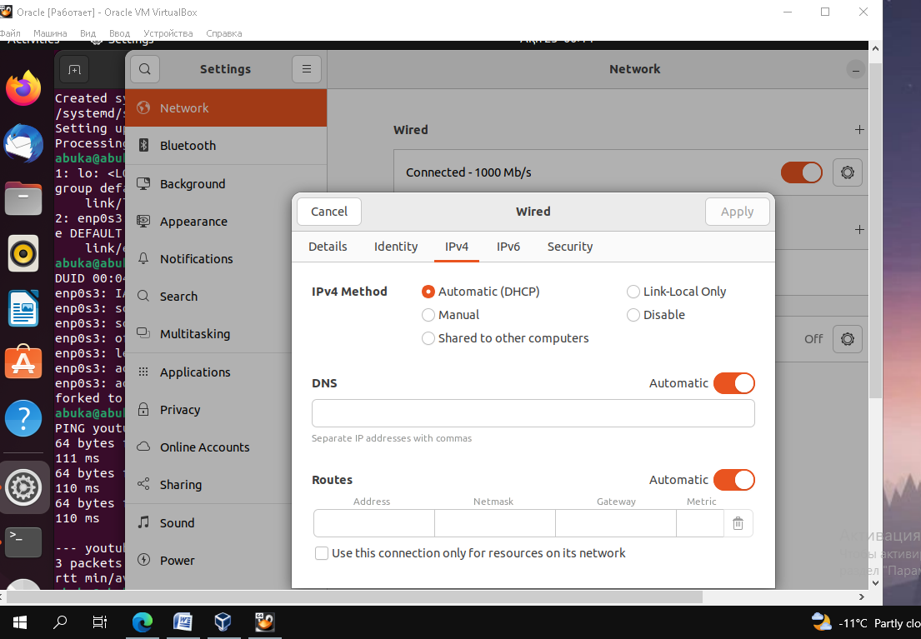

**2.2.2. NAT eth0 and eth1 connection**

NAT – method of remapping IP addresses spaces into another by modifying information in IP headers while transferring across traffic. We did NAT set up with using iptables, their firewall allows to you set up control of traffic.

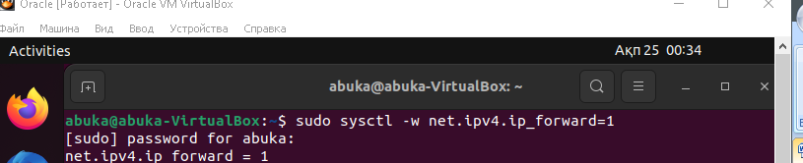

Picture 1. Enable IP forwarding, so Linux can act as a virtual router.

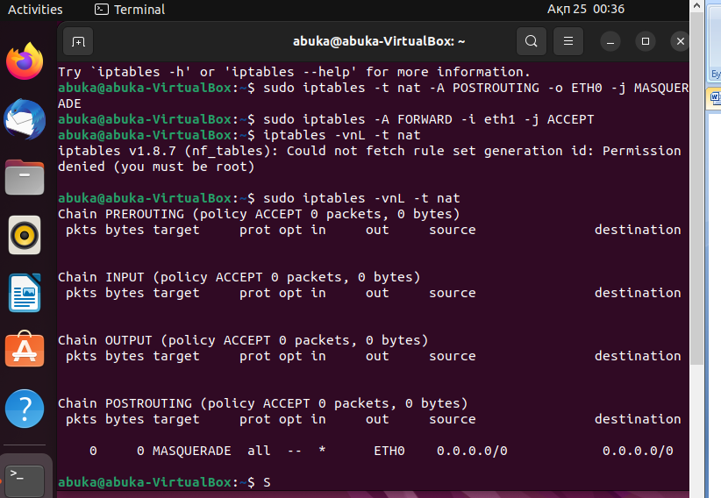

Picture 2. Set up iptables NAT by creating two **iptables** rules.

1st rule: translating incoming traffic from the external interface (**eth0**) to the internal interface (**eth1**).

2nd rule: accepting incoming traffic from the internal interface (**eth1**).

Checking out NAT iptables and saving them.**2.2.3. Proxy connection**

Proxy server – application program or system that acts as an intermediary for requests from clients seeking resources from servers. It provides a way to access internet pages indirectly, through middle server. So, we can bypass censorships, firewalls, bans, hiding IP address, security data. We used Microsoft Azure for hosting Linux Ubuntu server with Squid-caches, then we added OpenDNS with Pi-Hole.

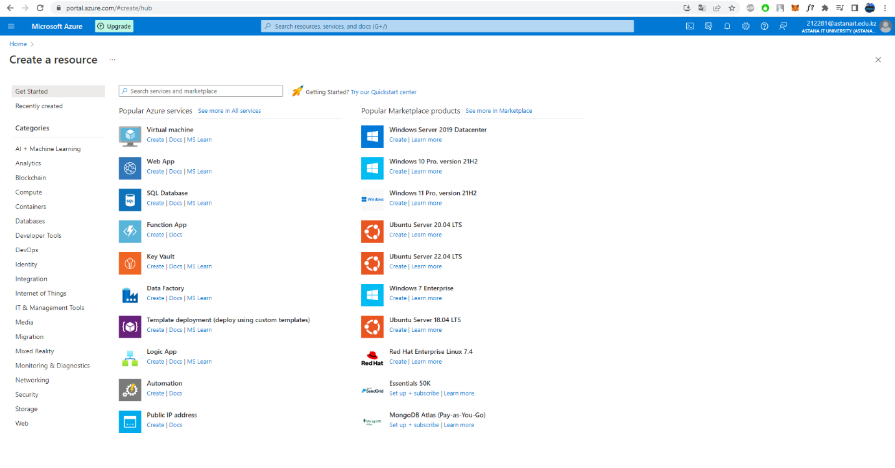

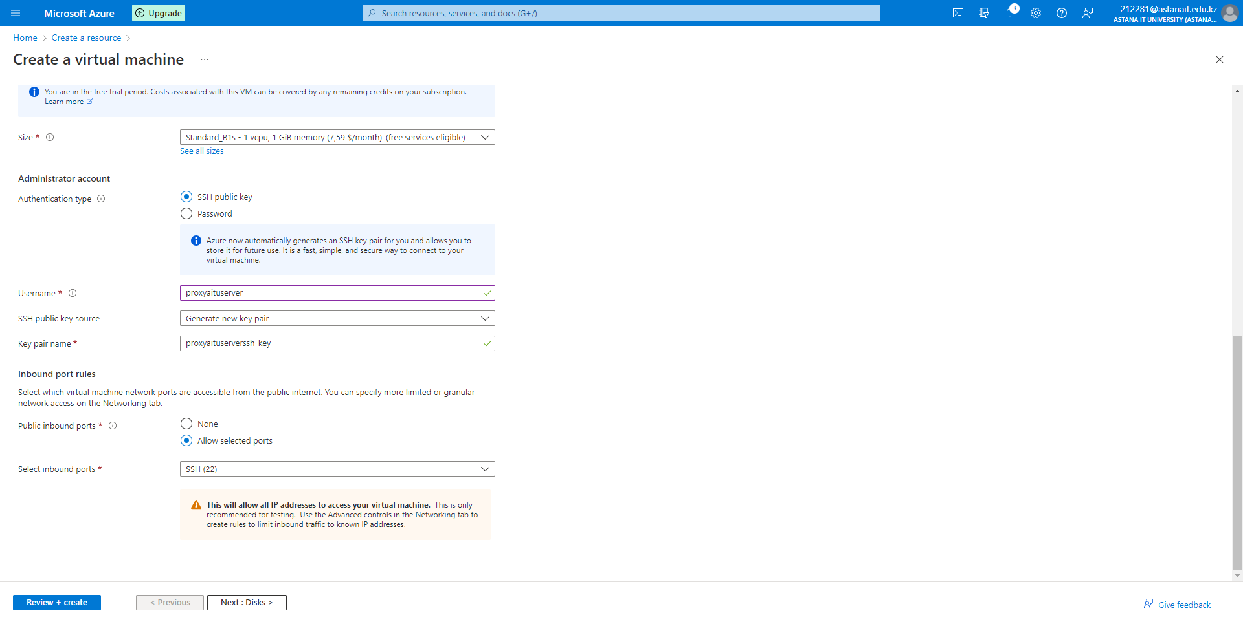****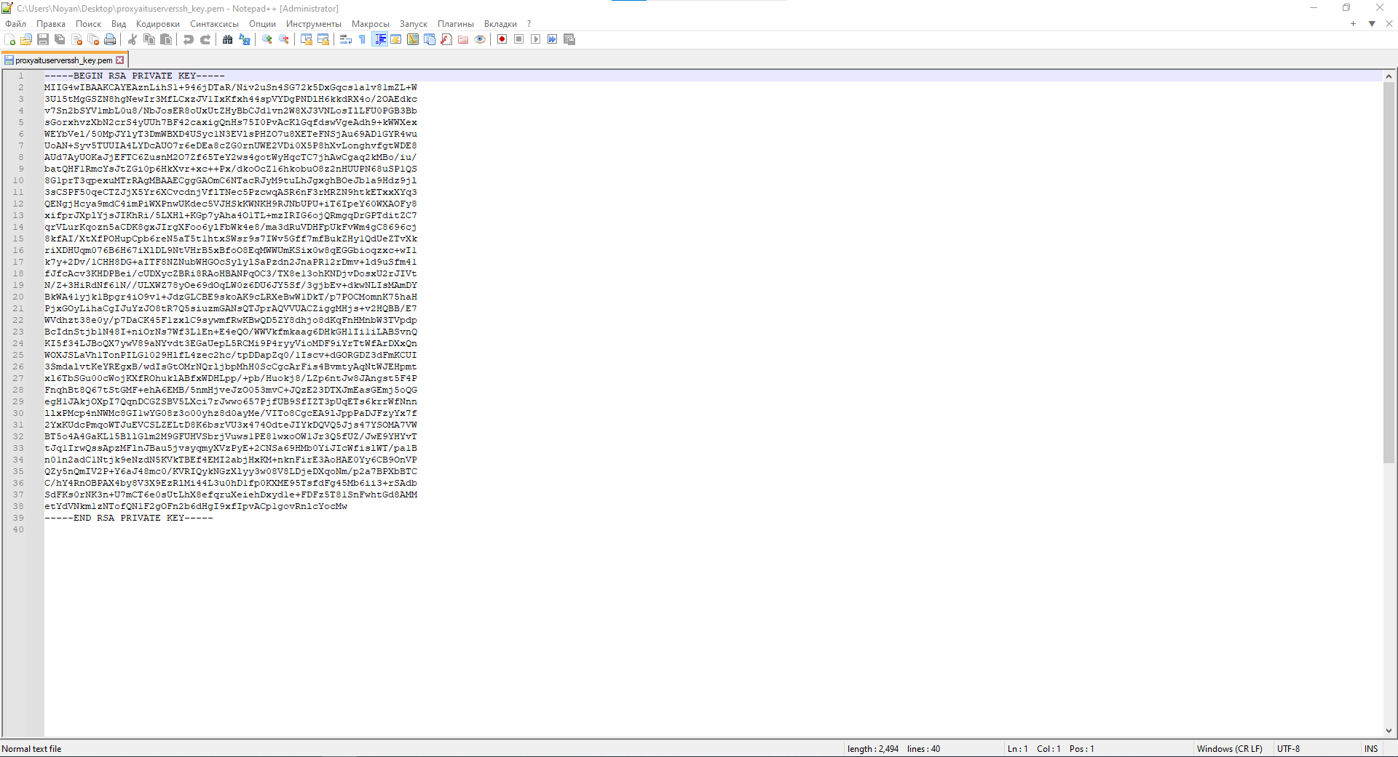

Picture 1. Deploying Linux Ubuntu 22.04 LTS server (username proxyaituserver, ssh key auth file).

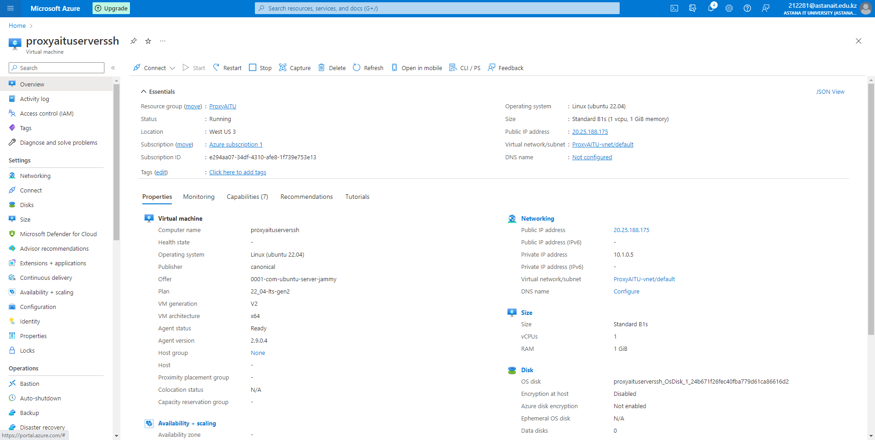

Picture 2. Brief information of our server (Public IP, Private IP, OS, etc.).

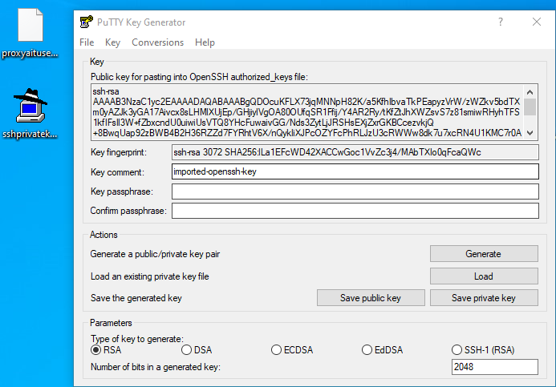

Picture 3. PuTTY key translator from ssh to ssh-rsa.

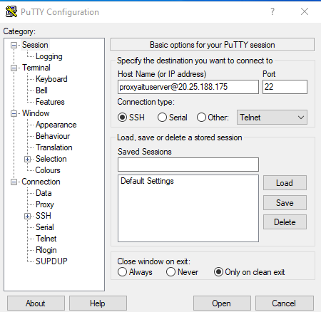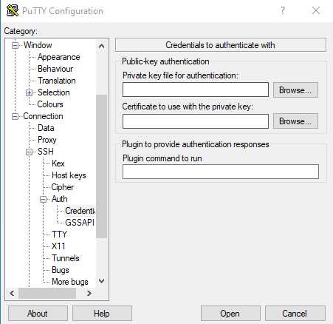

Picture 4. Connecting to server via ssh-rsa key (hostname [proxyaituserver@20.25.188.175:22](mailto:proxyaituserver@20.25.188.175:22)).

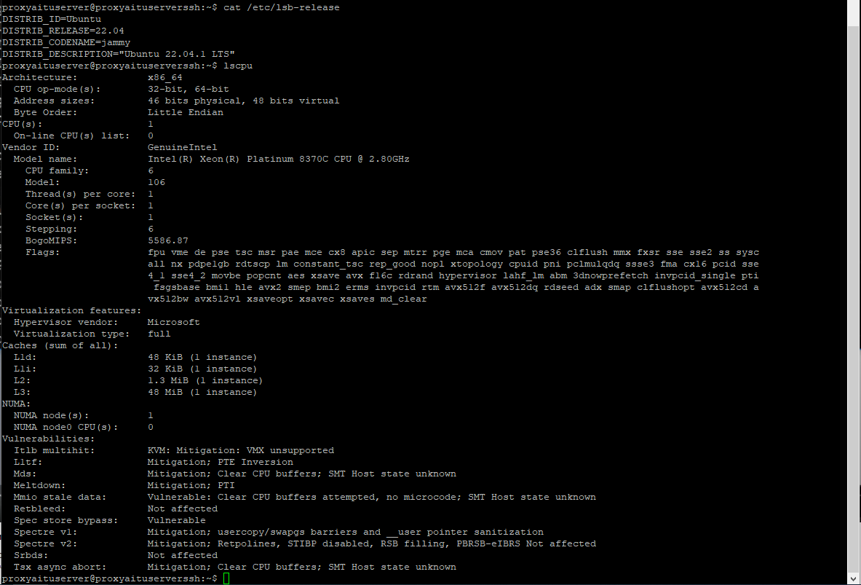

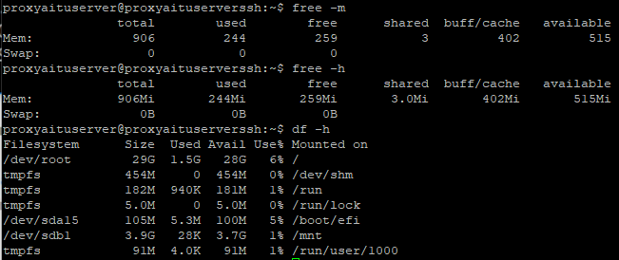

Picture 5. Checking real configuration of our server.

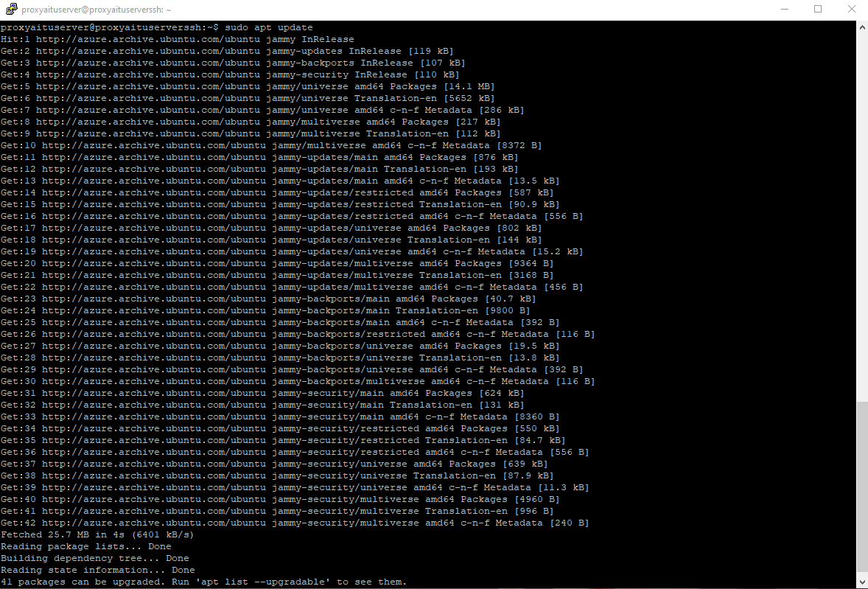

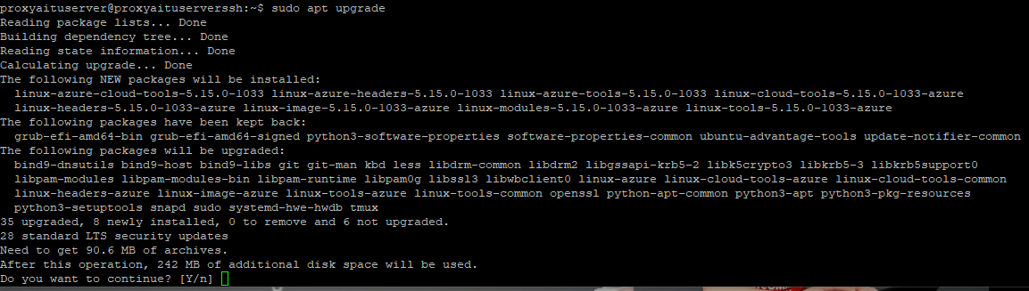

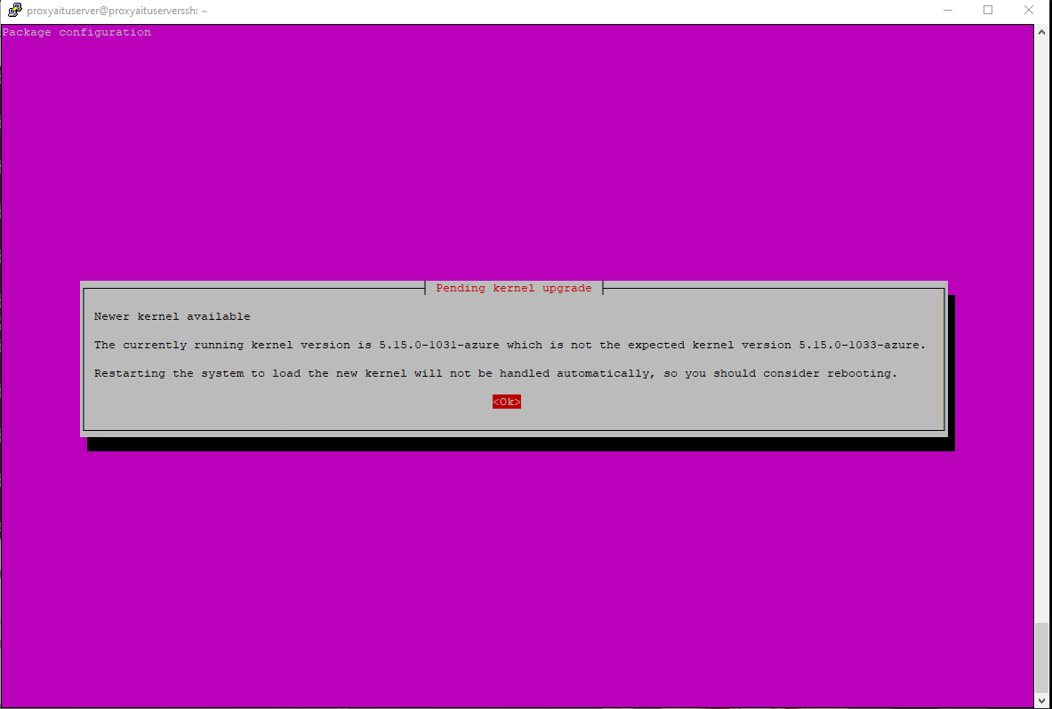

Picture 6. Installing and upgrading last version of system packets with linux kernel (sudo apt update, sudo apt upgrade).

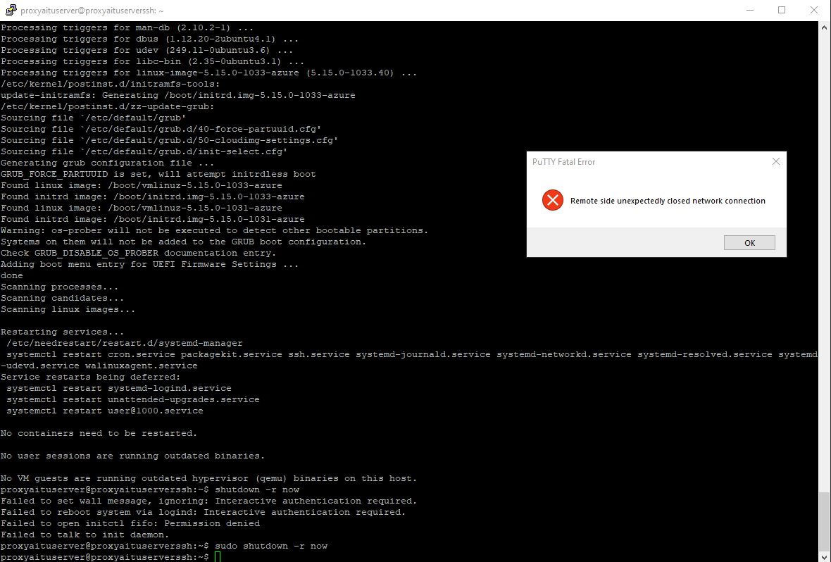

Picture 7. Then we need to reload server to boot new kernel as well.

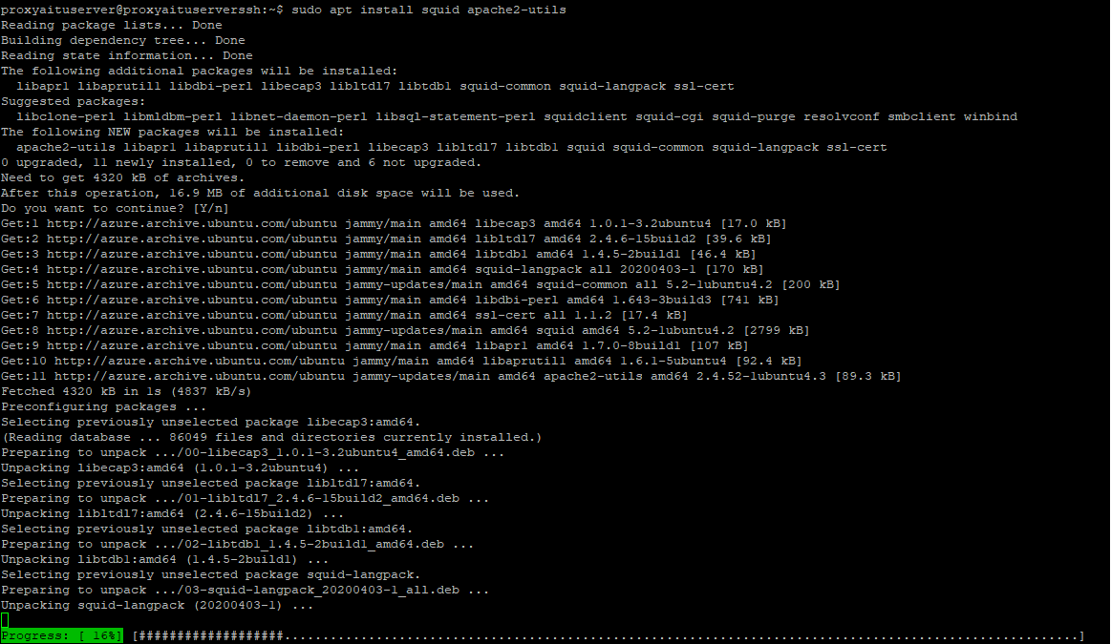

Picture 8. Installing squid-cache for proxy settings and apache2-utils for user authorization.

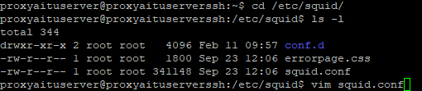

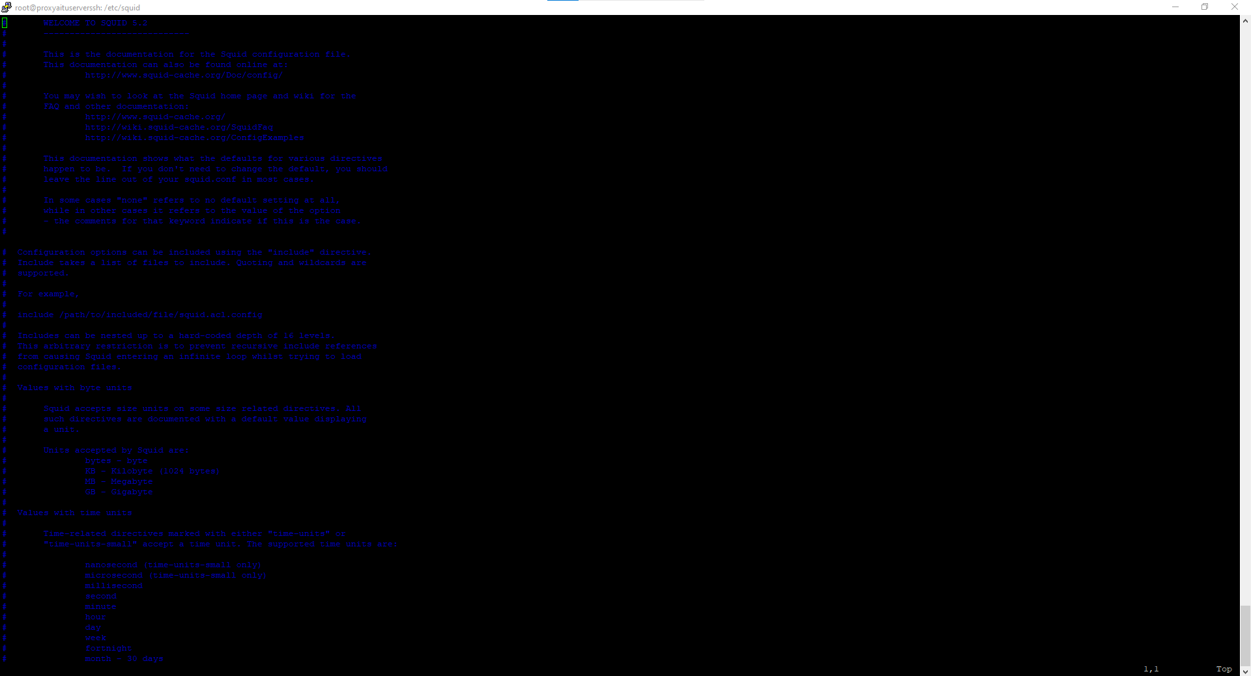

Picture 9. In /etc/squid/squid.conf we have basic configuration of proxy connection or filters, therefore need to write personal custom configuration.

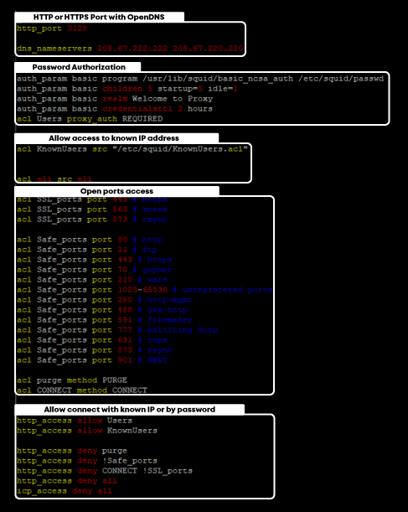

Picture 10. First part of our custom-made proxy squid.conf file.

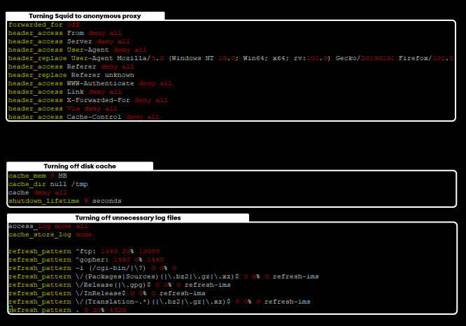

Picture 11. Second part of our custom-made proxy squid.conf file.

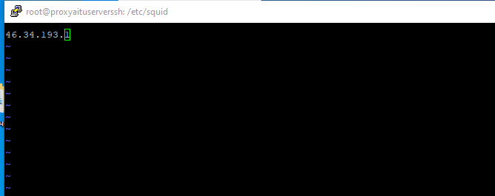

Picture 12. Adding our IP address to known IP (46.34.193.1).

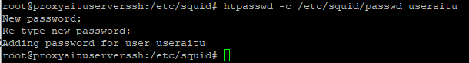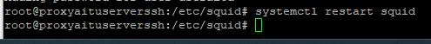

Picture 13. Creating new user (username useraitu, password aitucisco), also restarting proxy to start it working.

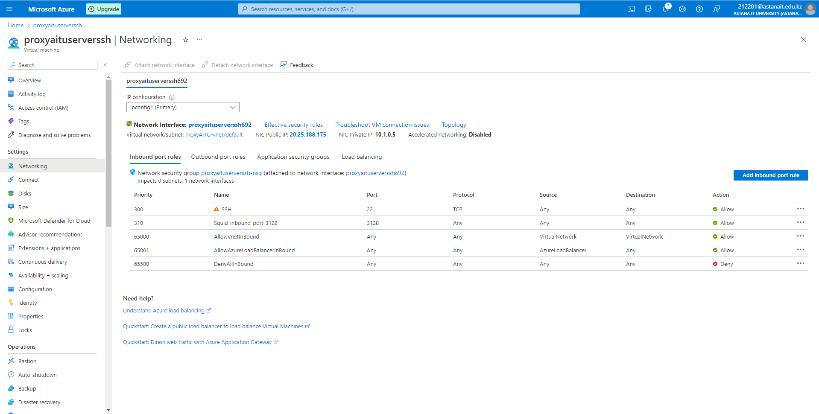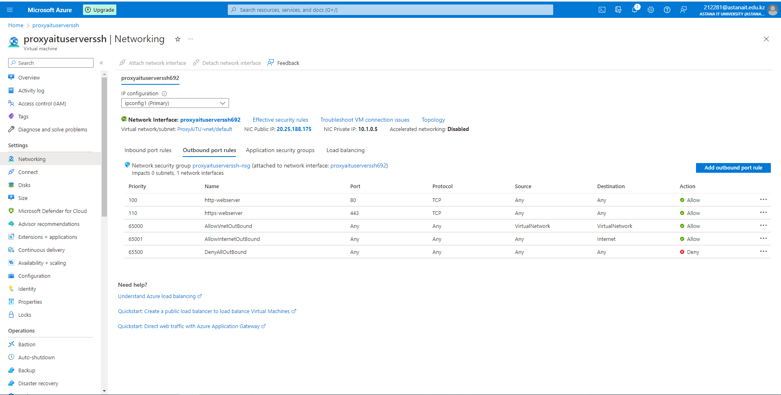

Picture 14. Making inbound and outbound rules for http or https connections of proxy port 3128.

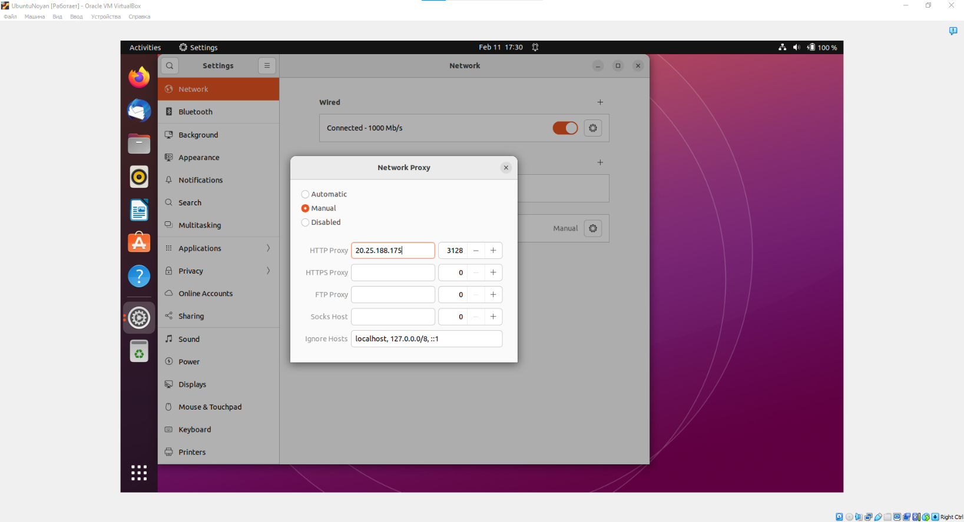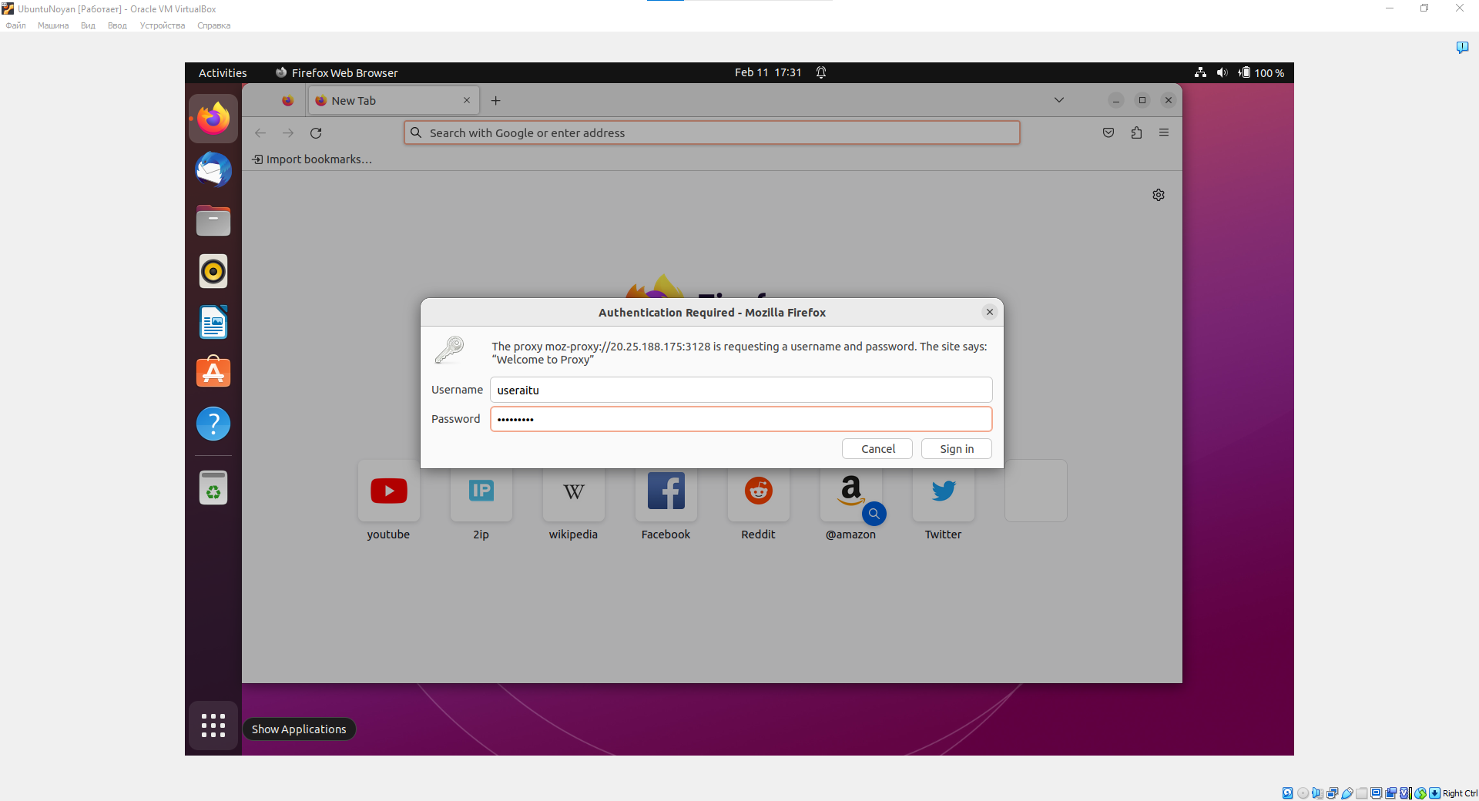

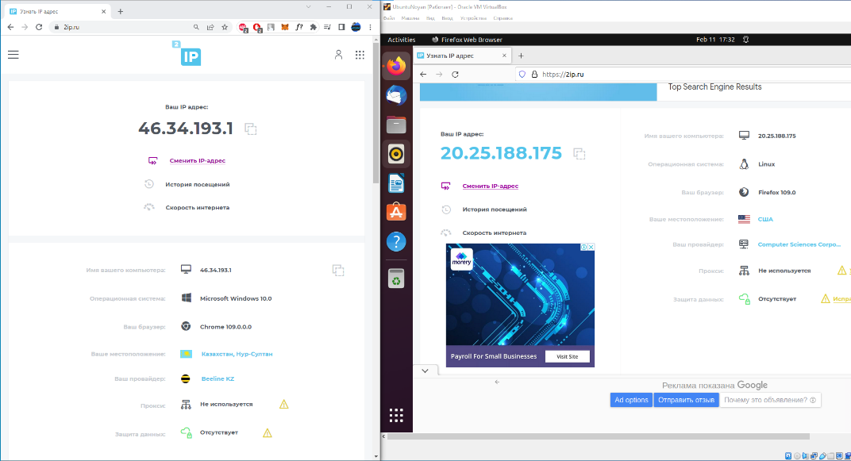

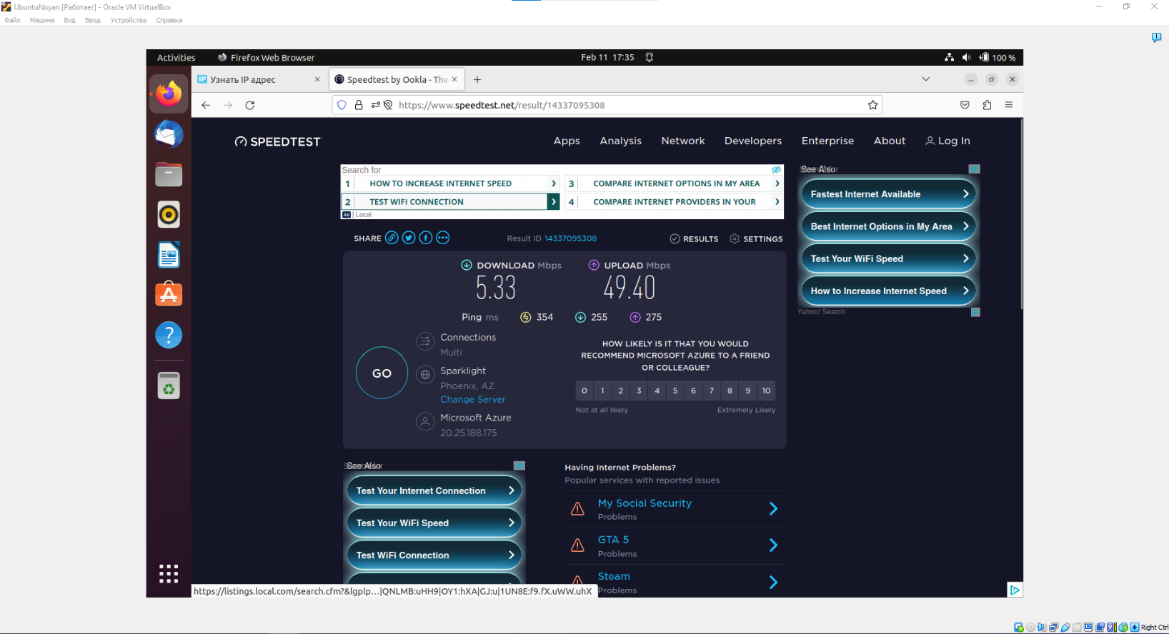

Picture 15. Checking proxy server connection (46.34.193.1 without proxy, 20.25.188.175 with proxy).



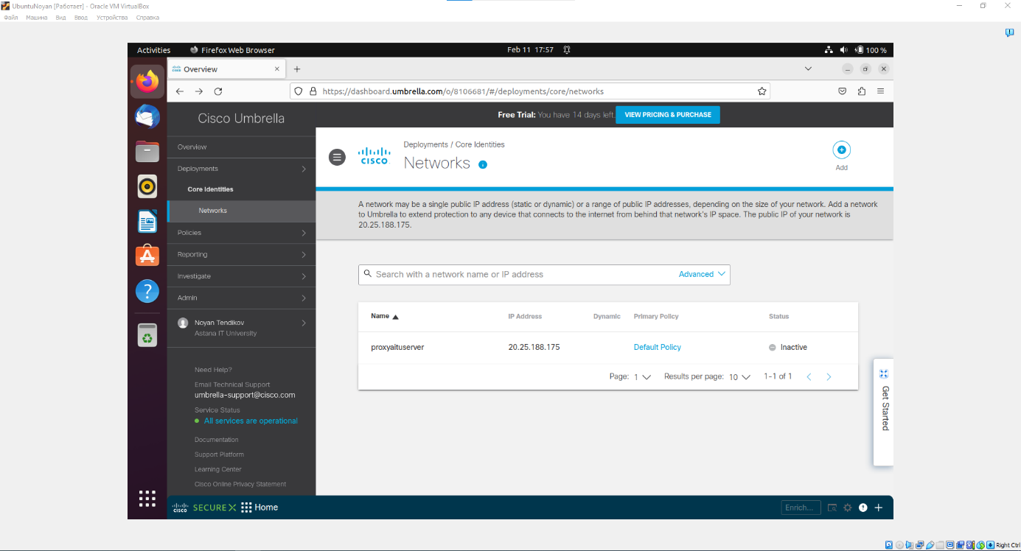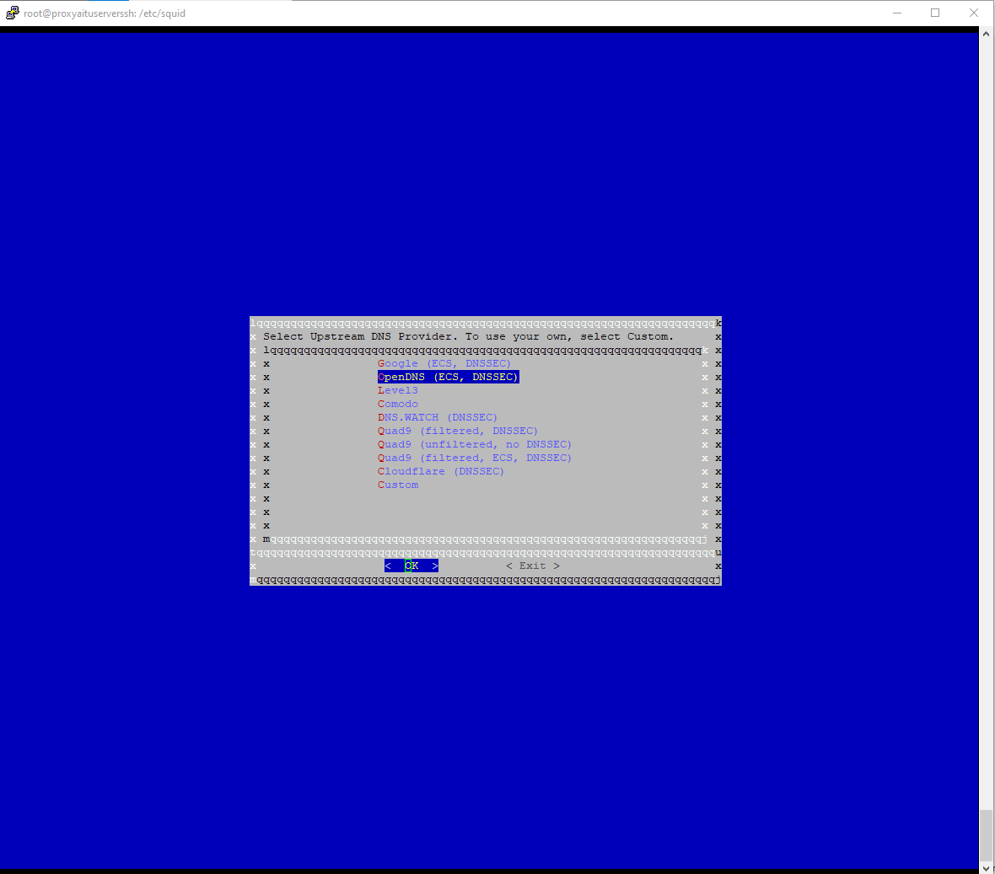

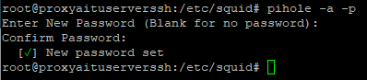

Picture 16. Building on Pi-Hole and OpenDNS Cisco to adblock connection for specific website or making firewall on proxy.

**2.3. Task 3 – Linux Kernel**

**2.3.1. Compiling custom Linux Kernel**

There are many types of Linux Kernel deployments or installations. We will cover only main of them: monolithic kernel via kernel archives and make oldconfig, custom kernel by make menuconfig, and kernel mainline.

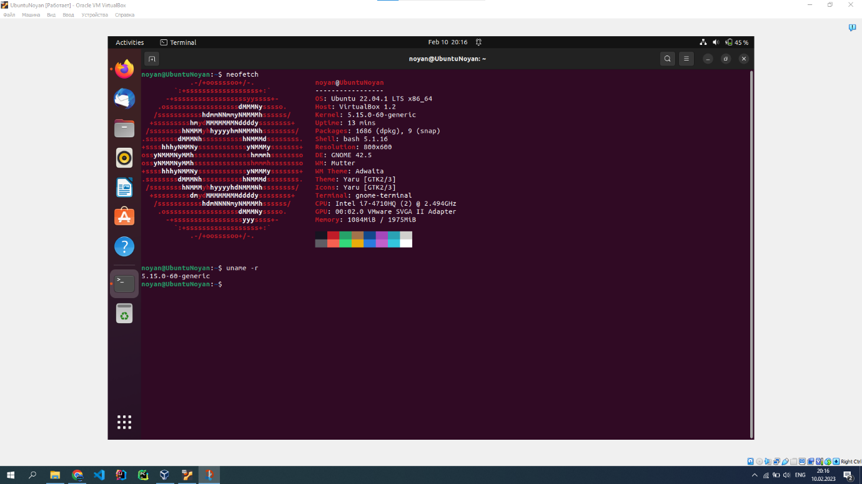

Picture 1. Checking our version of kernel with uname -r or neofetch (our current kernel 5.15.0-60-generic).

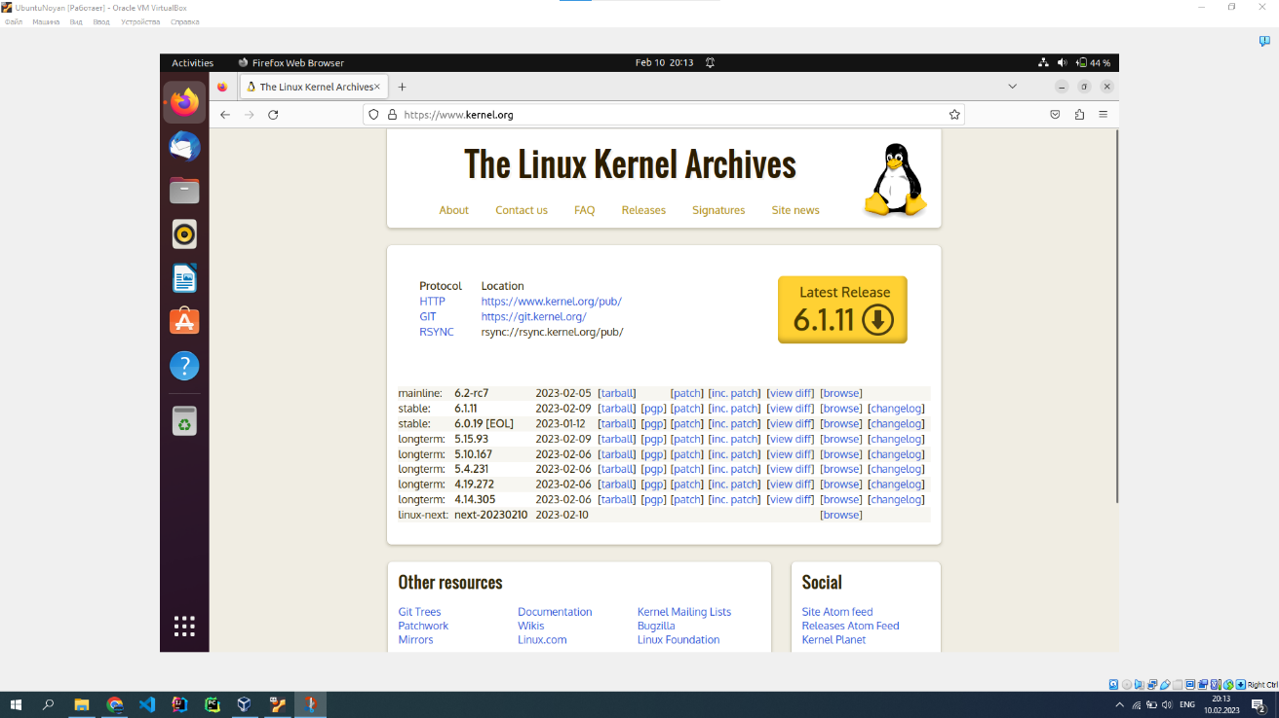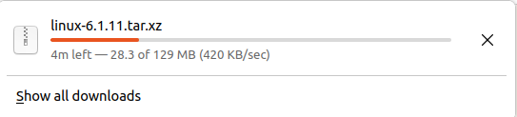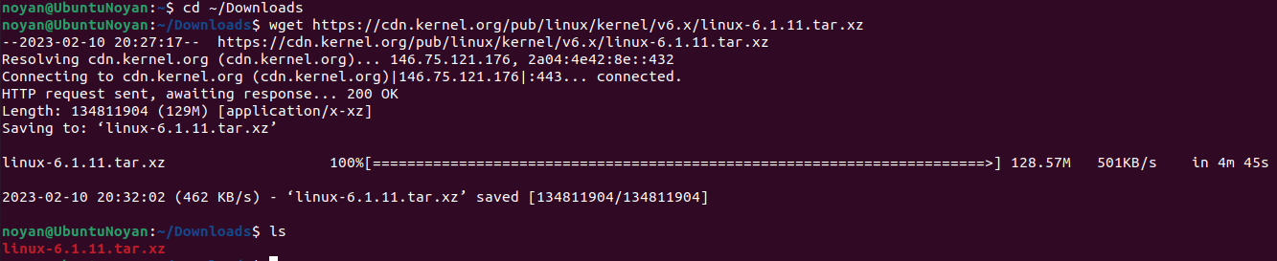

Picture 2. Going to Linux Kernel Archives, we need to download only stable release (now it is 6.1.11). We can download kernel image manually or with bash wget or git.



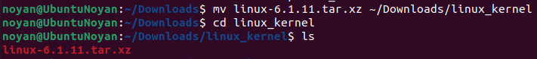



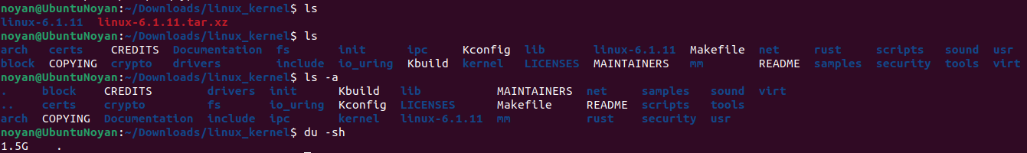

Picture 3. Unzipping linux kernel image to dir linux_kernel in ~/Downloads.

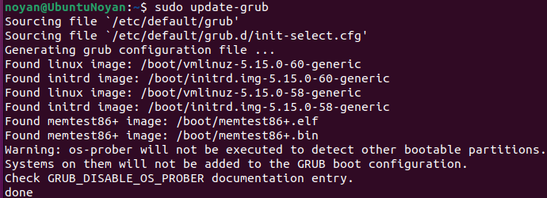

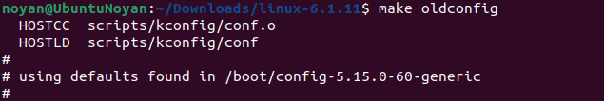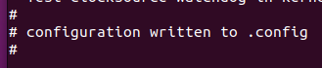



Picture 4. This is the way of installation of Linux Kernel based on make oldconfig or make olderconfig.



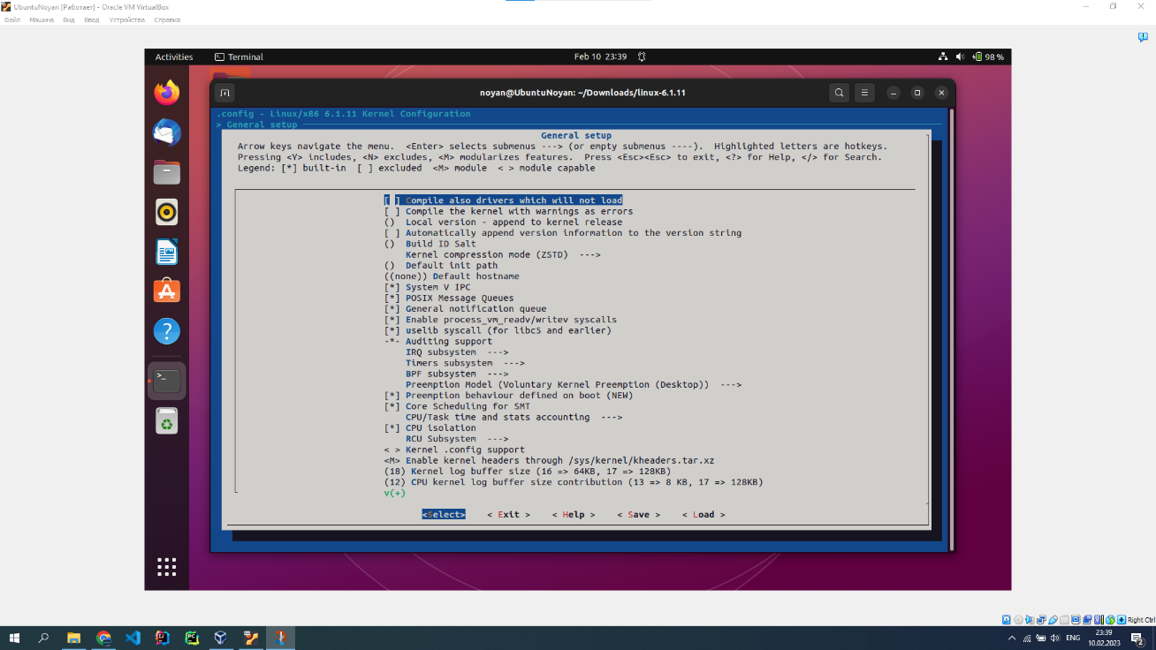

Picture 4. This is how to make installation of Linux Kernel with make menuconfig. You need to configure every part of kernel (modules) step by step.

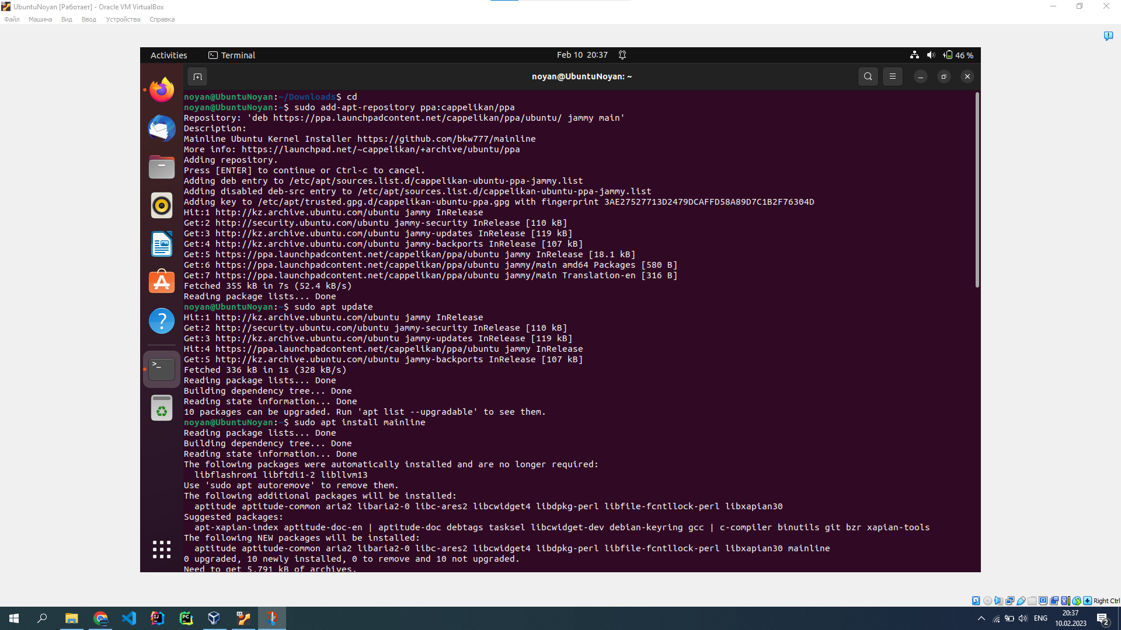





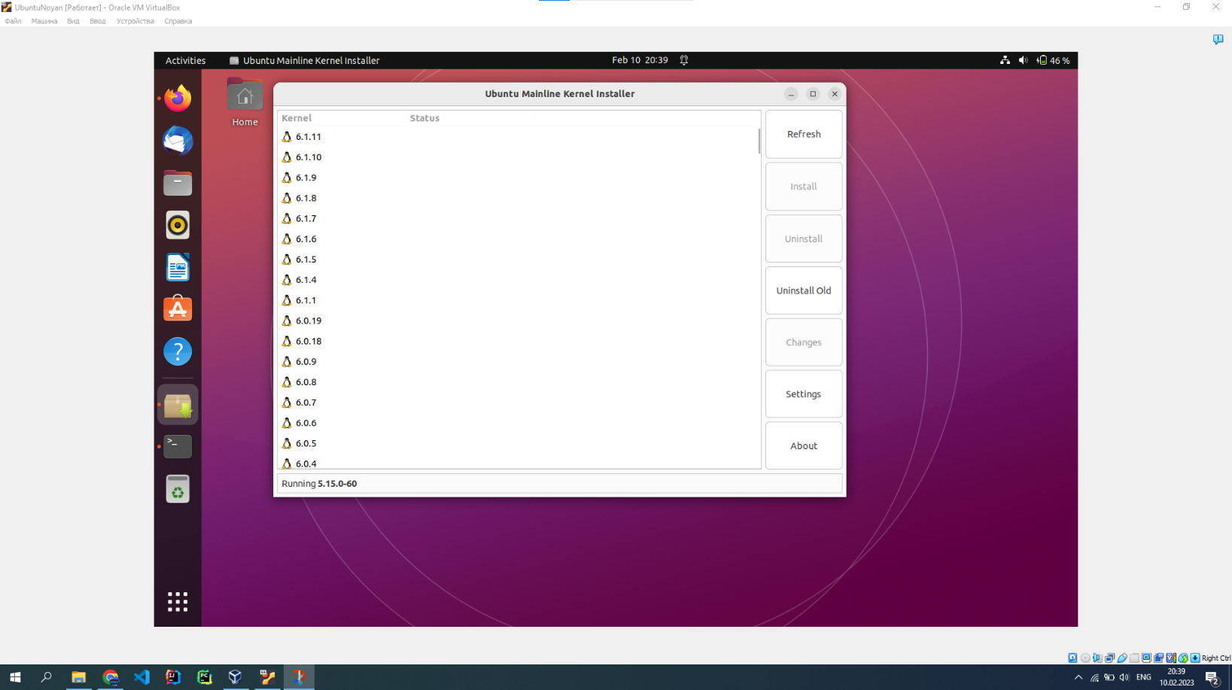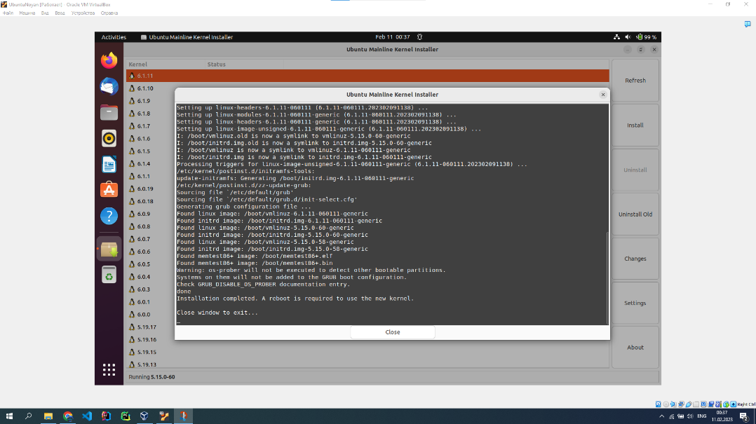

Picture 5. If you aren’t sure about quality of your installation or you don’t know how to do it, you can make it with mainline kernel installer.

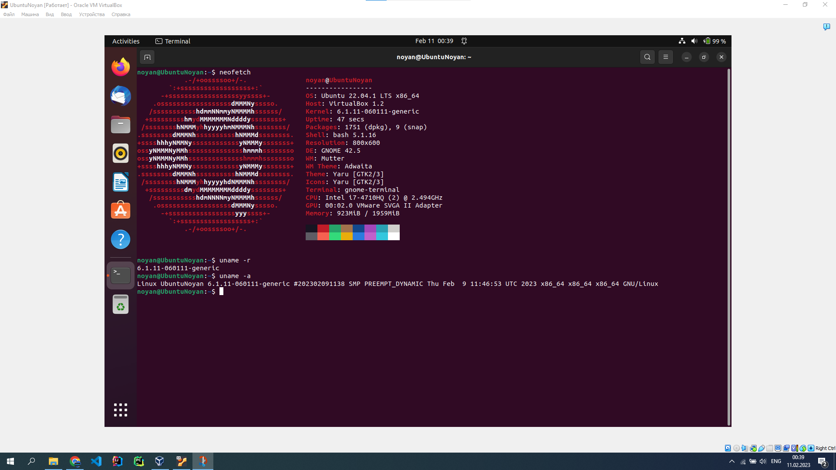

Picture 6. We tried all 3 methods of installing, so we got no problems with OS or Kernel stability (6.1.11 version).

**2.3.2. Compiling custom Linux Kernel**

Linux Kernel Modules – components of kernel which could be loaded or unloaded dynamically while OS is running. They provide additional functionality or support to hardware devices, files, system calls. Therefore, we developed our 3 simple useful kernel modules: “Current Timer Module”, “Hello World Module”, “Imitation Device Callbacks Module”. All modules code in our github of project (https://github.com/NoyanTM/osc-final-project).

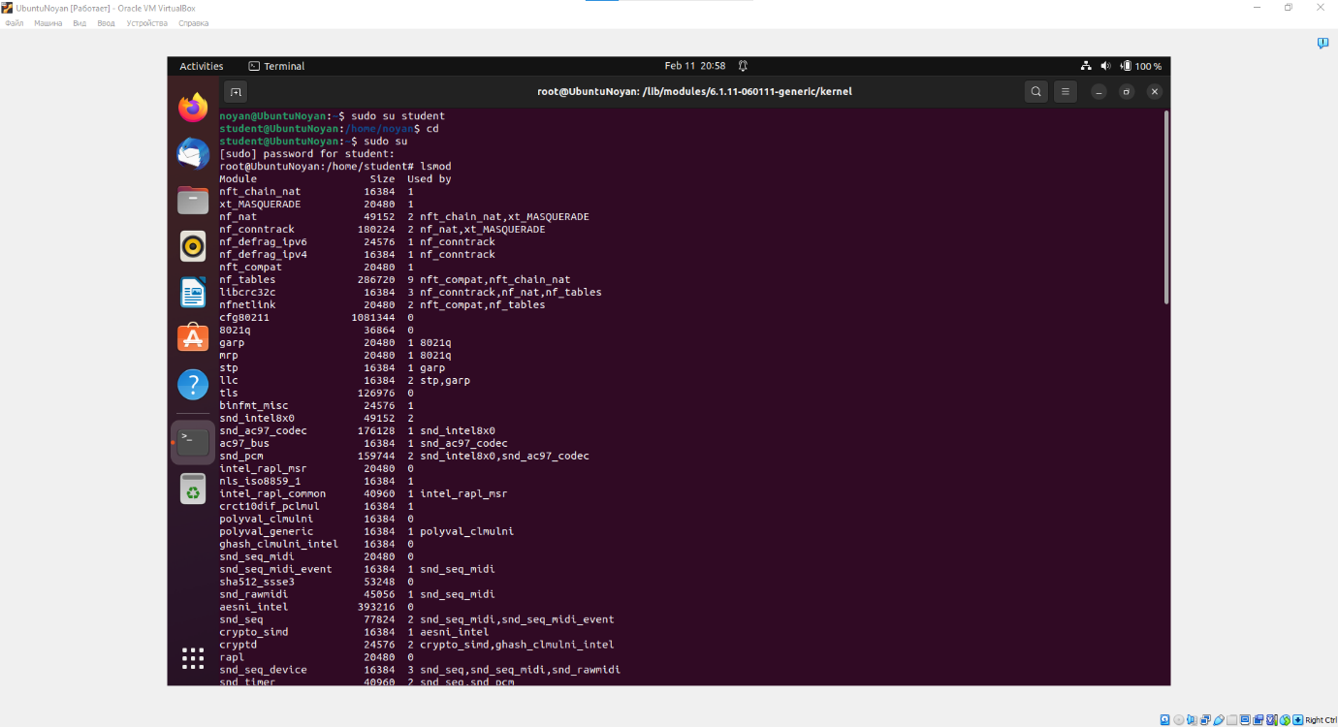

Picture 1. Searching for current active kernel modules – lsmod.

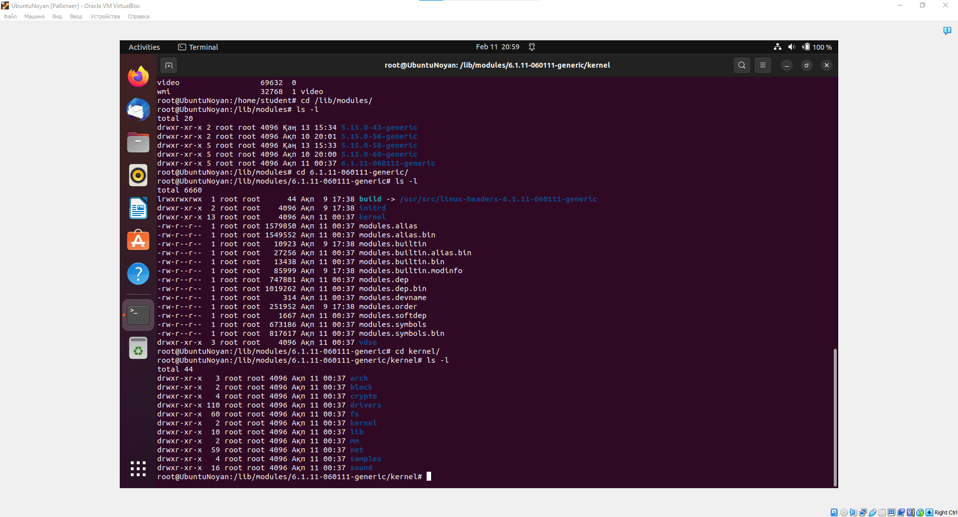

Picture 2. Types of main kernel modules types in Linux (arch, block, crypto, etc.).

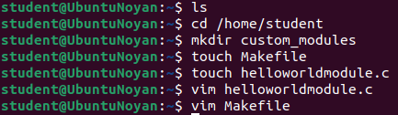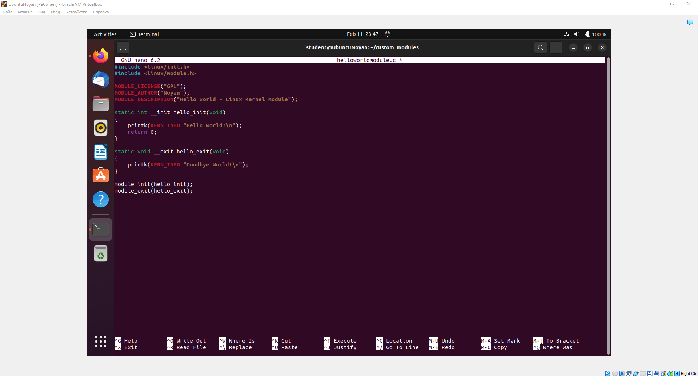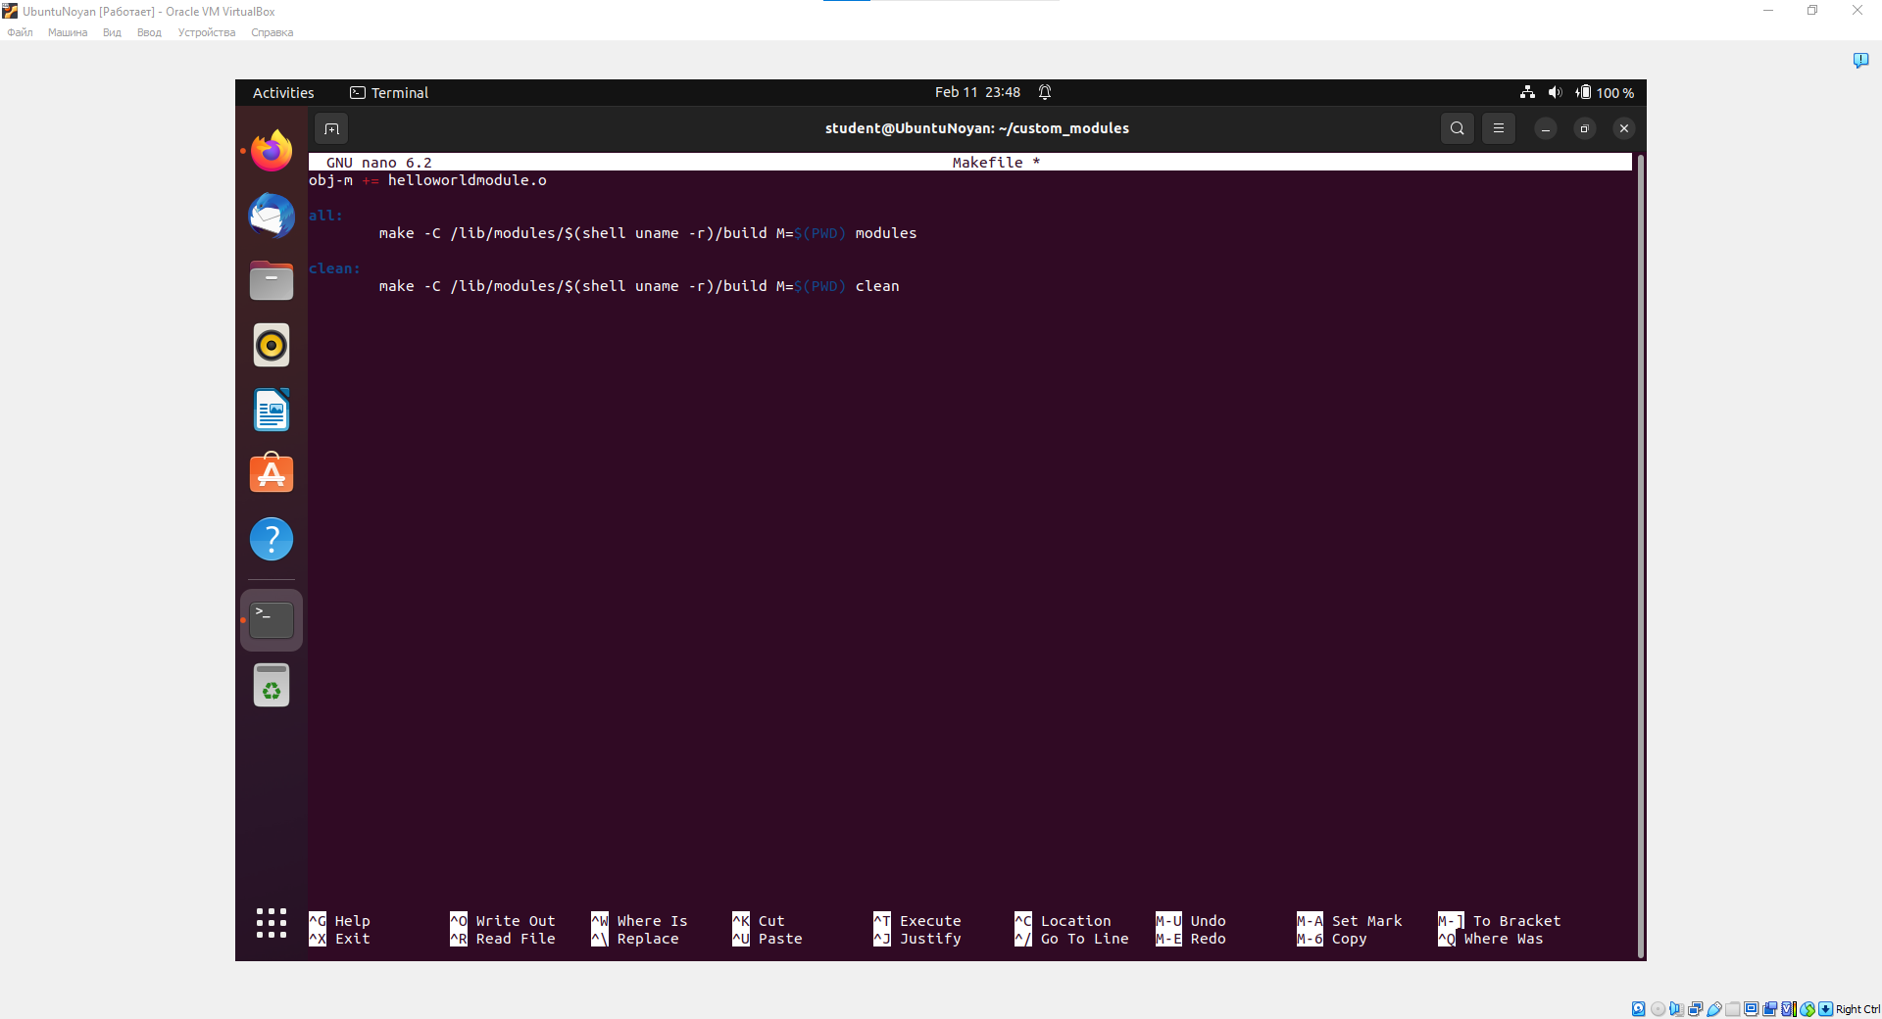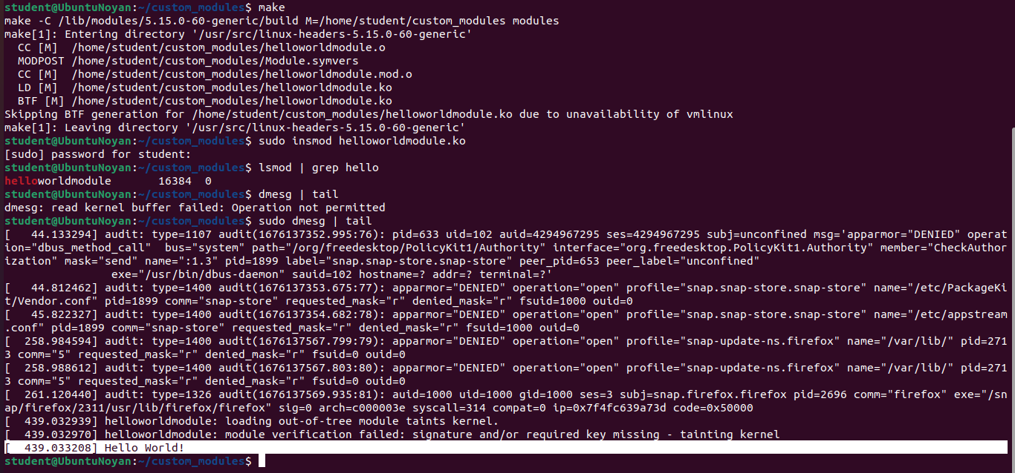

Picture 3. “Hello World Module” – writing hello world when active in kernel. helloworldmodule.c – our kernel module; Makefile – compiler for helloworldmodule.c; sudo insmod helloworldmodule.ko - load the module into the kernel, etc; lsmod | grep (module name here) – finding our specific module in kernel; dmesg | tail – checking kernel buffer to find callbacks of our module;

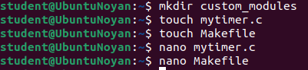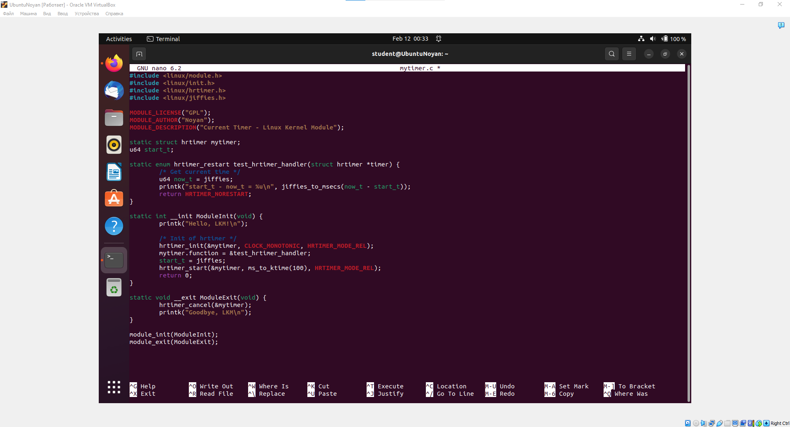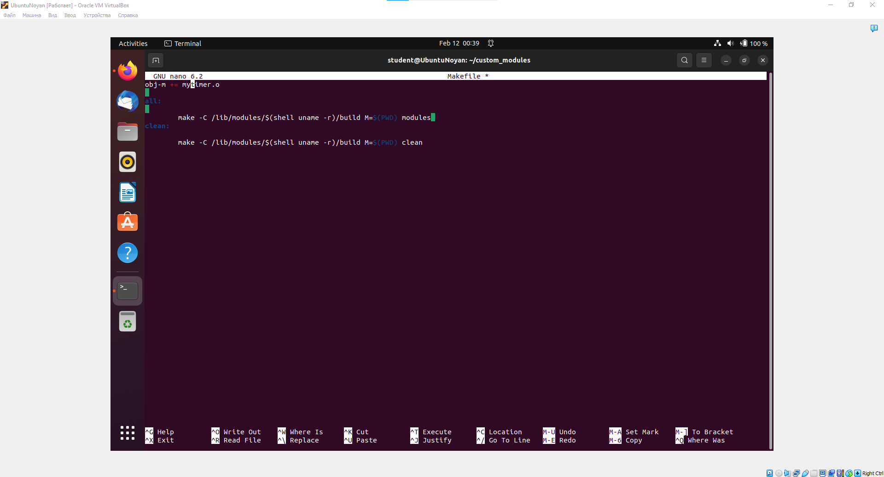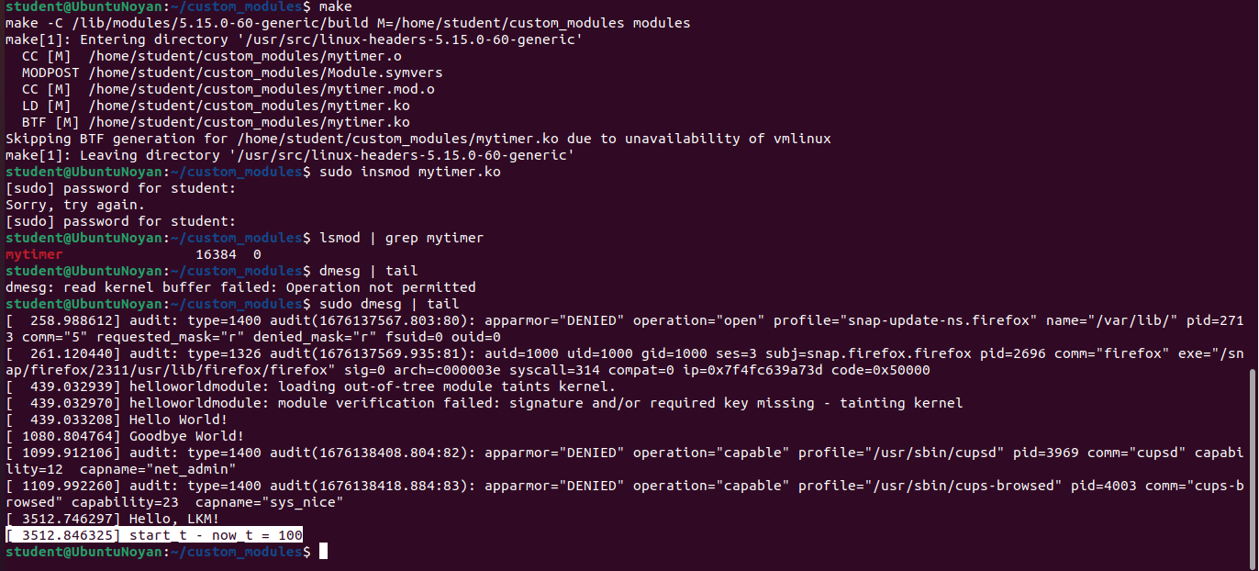

Picture 4. “Current Timer Module” – calculating timings for specific boundaries of time. mytimer.c – our kernel module; Makefile – compiler for mytimer.c; sudo insmod mytimer.ko - load the module into the kernel, etc; lsmod | grep (module name here) – finding our specific module in kernel; dmesg | tail – checking kernel buffer to find callbacks of our module;

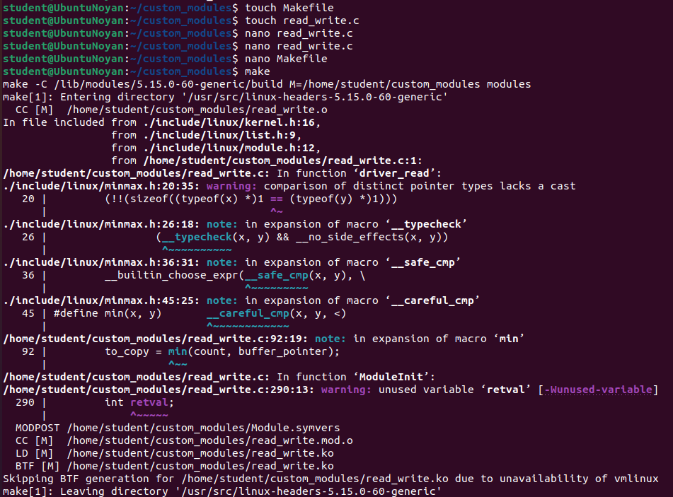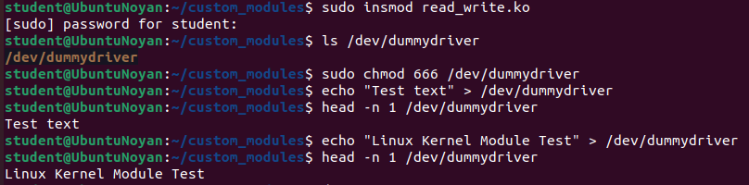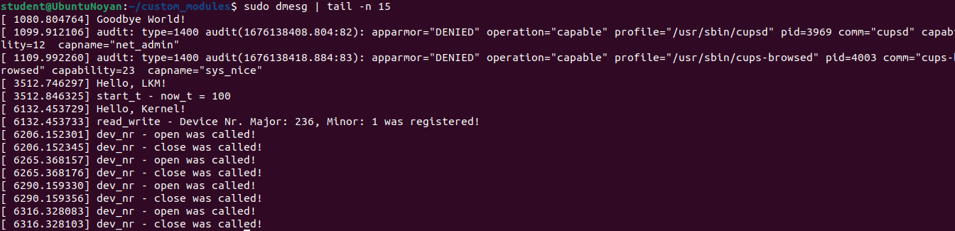

Picture 5. “Imitation Device Callbacks” – writing about all changes or accesses in /dummydriver and its Nr in devices. read_write.c – our kernel module; Makefile – compiler for read_write.c; sudo insmod read_write.ko - load the module into the kernel, etc; lsmod | grep (module name here) – finding our specific module in kernel; dmesg | tail – checking kernel buffer to find callbacks of our module;

**3. Conclusion**

**3.1. Reflection and summary**

Overall, We have successfully completed our final project for OSC, where we have acquired crucial skills that will be beneficial for our future as cybersecurity specialists or system administrators. These skills include adding new users to the operating system, establishing internet connections through various methods, and creating a Linux OS kernel with kernel modules.

Adding a new user account is an important step in securing the system and granting appropriate permissions to different users. Testing the different internet connections can help identify any issues or limitations with the network configuration. Developing a kernel module can enable the system to perform new or customized functionality.

In conclusion, the hands-on activities of administering a Linux system, including managing users and connecting to the internet, have helped us gain a better understanding of the underlying systems and protocols used in the real world. Additionally, the work done on the virtual Linux machine and kernel module has the potential to enhance system functionality and security. This report can serve as a valuable reference for those interested in similar tasks, as well as a starting point for further exploration and development in this area.

4. References and bibliography materials

Github Project Link -

Squid Proxy - <http://www.squid-cache.org/>

The Linux Kernel Module Programming Guide - <https://sysprog21.github.io/lkmpg/>

Docs of Linux Kernel - <https://docs.kernel.org/>

Microsoft Azure for proxy server deployment - <https://azure.microsoft.com>